Name: ___________________________________________________________ Period: _______________

McDonalds and Market Area
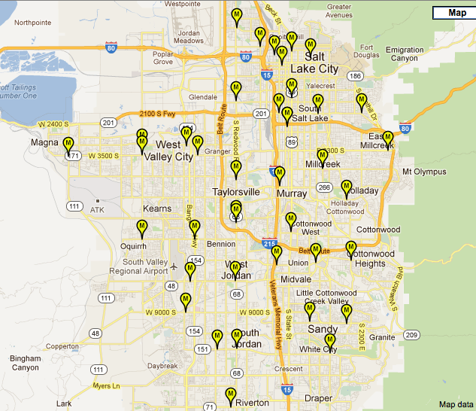
On the map below, draw the hexagon representing market area around each of the indicated McDonalds locations. Then answer the questions on the back of this page.
- Are the market areas the same size for each of these locations? Why or why not?
- Are the thresholds the same for each of these locations? Why or why not?
- What influences the placement of these locations?
- Are there gaps between locations? Where do people who live or work in these gaps go to eat?
- Where would you locate the next McDonalds location? Why?

