Find a picture online of your individual and copy and paste it into this box by highlighting all of the text in this box and hitting “Control +V.” Resize the picture if necessary. If you have difficulty you can print a picture and glue it into this box after you print the assignment.

Personal Information
Facts:

Role:

Favorite
Music:

Favorite
Books:

In this box, type any interesting facts about your individual that help illustrate his or her character. You should include at least 5 facts.

In this box, type any facts about your individual that explains his or her role in the American Revolution. You should include at least 3 facts.
Use the personality of your figure and come up with some specific songs, music artists, or music genres that you think he or she would have liked, and explain your choices.
Use the personality of your figure and come up with at least three books or authors that you think he or she would have liked. Explain why he or she liked them.
Type Name of Character Here

Basic Information
Birthday: Type Here
Sex: Type Here
Hometown: Type Here
Occupation: Type Here
Social Class: Type Here

facebook Home Profile Friends Inbox
In this box, type the names of at least five groups that you think your character would be a part of on facebook.
Group
Wall

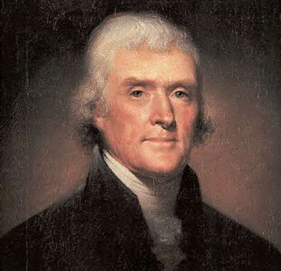
Reply:
Jefferson wrote:
Replace this text. What would Jefferson write on your wall? If you are Jefferson, leave a message in reply to another character.
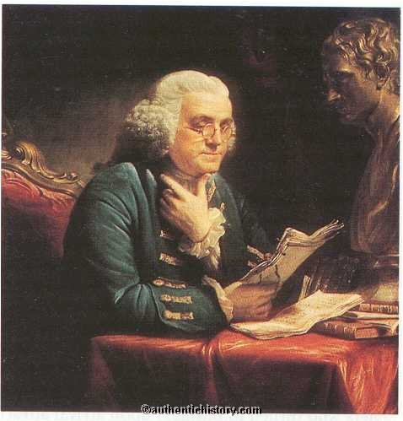
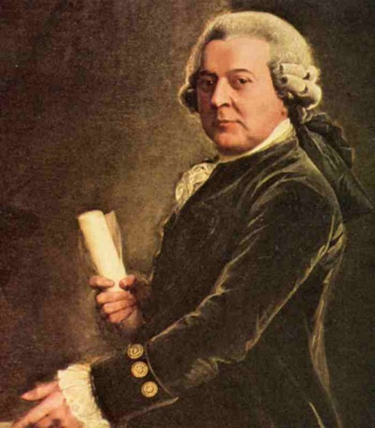
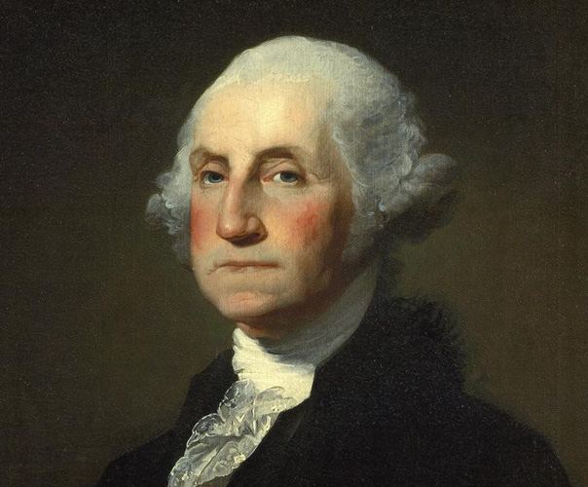
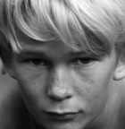
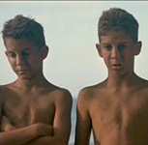
Adams wrote:
Replace this text. What would Adams write on your wall? If you are Adams, leave a message in reply to another character.
Washington wrote:
Replace this text. What would Washington write on your wall? If you are Washington, leave a message in reply to another character.

Franklin wrote:
Replace this text. What would Franklin write on your wall? If you are Franklin, leave a message in reply to another character.

Dill wrote:
Replace this text. What would Simon write on your wall? If you are Simon, you can leave a message in reply to another character.

